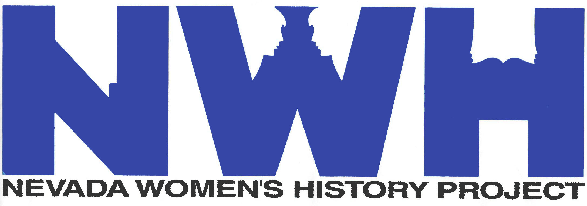

NEVADA WOMEN’S HISTORY PROJECT
(Membership is for January thru December of each year)

Thank you for your ongoing support of the Nevada Women’s History Project. Our new year is here and it is time to renew your membership. You are vital to maintaining our educational website of women’s biographies and interviews, having special events and to offset the operational costs of the NWHP.

Please notice that we have added a lifetime membership category, Best Friend Forever. Membership comes with an event discount and a newsletter. All levels of membership may be tax deductible since NWHP is an educational non-profit.

Membership Levels

Individual $30.00 __________
Family of Two $55.00 __________
Friend $100.00 __________
Good Friend $250.00 __________
Best Friend $500.00 __________
Best Friend Forever $1,000.00 __________

Organization $50.00 __________
Corporate Sponsor $250.00 __________

I also enclose an additional _____________________donation for the NWHP.
(amount)

NAME: ______________________________________________________________________________________

MAILING ADDRESS: _______________________________________________________________________

______________________________________________________________________________________________

HOME PHONE: ___________________________ CELL PHONE: _________________________________

EMAIL ADDRESS: _________________________________________________________________________

Date: ____________________ Check No: ________________

____________ I prefer the digital copy of the newsletter instead of the paper copy.

‡ If you attend a NWHP event your photo may appear in our paper or digital materials.
Check here if you do not want us to publish your photo. _____
Thank You!
770 SMITHRIDGE DRIVE, SUITE 300 – RENO, NV 89502
(775) 786-2335 FAX (775) 826-6865
www.nevadawomen.org www.suffrage100NV.org nwhp@pyramid.net

Our Mission:
To provide visibility and support for the gathering and dissemination of history
about the roles and contributions of all Nevada women.

Nevada Women’s History Project is an educational Nevada Nonprofit Corporation and a 501(c)(3).
Contributions or donations may be tax deductible

